**9. Web Integration: Publishing to Tableau Public**

**📘 Overview:**

**Web integration** involves publishing dashboards and visual stories to a public platform where stakeholders can **access, interact, and gain insights** in real time. In this project, **Tableau Public** was used for hosting and sharing dashboards with a wider audience.

**🎯 Purpose of Publishing:**

Publishing dashboards serves several important functions:

* ✅ **Monitor Key Performance Indicators (KPIs):** Enables tracking of site distribution, risk factors, and regional trends.
* ✅ **Improve Decision-Making:** Allows cultural organizations, researchers, and policy-makers to make informed, data-driven decisions.
* ✅ **Enhance Communication:** Easily share findings and visual summaries with stakeholders, academic communities, or the general public.
* ✅ **Real-Time Access:** Provides a centralized online platform for dynamic interaction with data.

**🚀 Publishing Platform Used:**

* **Tool:** Tableau Public
* **Format:** Interactive Dashboards and Tableau Stories
* **Access:** Publicly viewable through shared URLs

**🧠 Key Benefits:**

* Cloud-hosted and accessible from anywhere
* Supports interactive filters, tooltips, and navigation
* No software installation required for end users
* Ensures transparency and visibility of insights

**✅ Result:**

All dashboards and visual stories developed during the project were successfully **published to Tableau Public**, allowing real-time interaction and presentation of findings on UNESCO World Heritage Sites.

Duration: 1 Hrs

Skill Tags:

Note:This process is also explained in the flask part mentioned below

Give the server address of your tableau public account and click on connect.

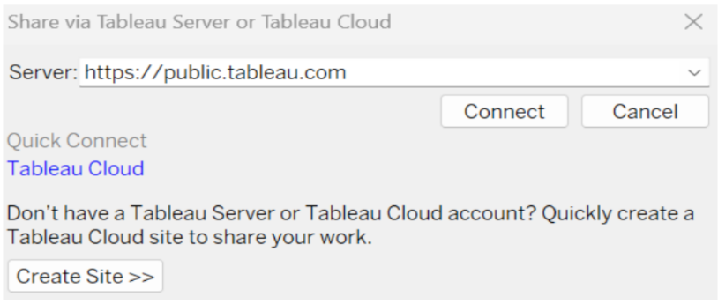

Step 2: Once you click on connect it will ask you for tableau public user name and password.

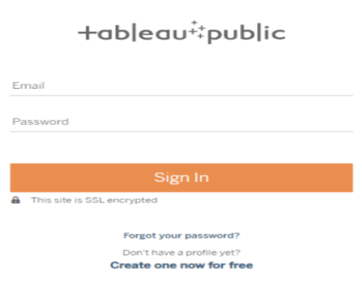

Once you login into your tableau public using the credentials, the particular visualization will be published into tableau public.

Note: While publishing the visualization to the public, the respective sheet will get published when you click on share option.



**Dashboard and Story embed with UI With Flask**

Duration: 1 Hrs

Skill Tags:

Explanation video link:[TableauFlask.mp4](https://drive.google.com/file/d/1b0YdPMco1685SywHrOMTFx7MMYpZ-3RH/view?usp=sharing)

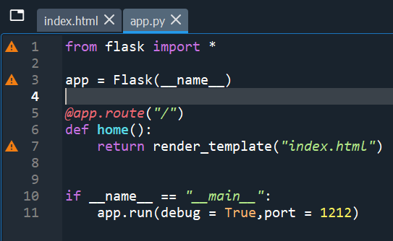

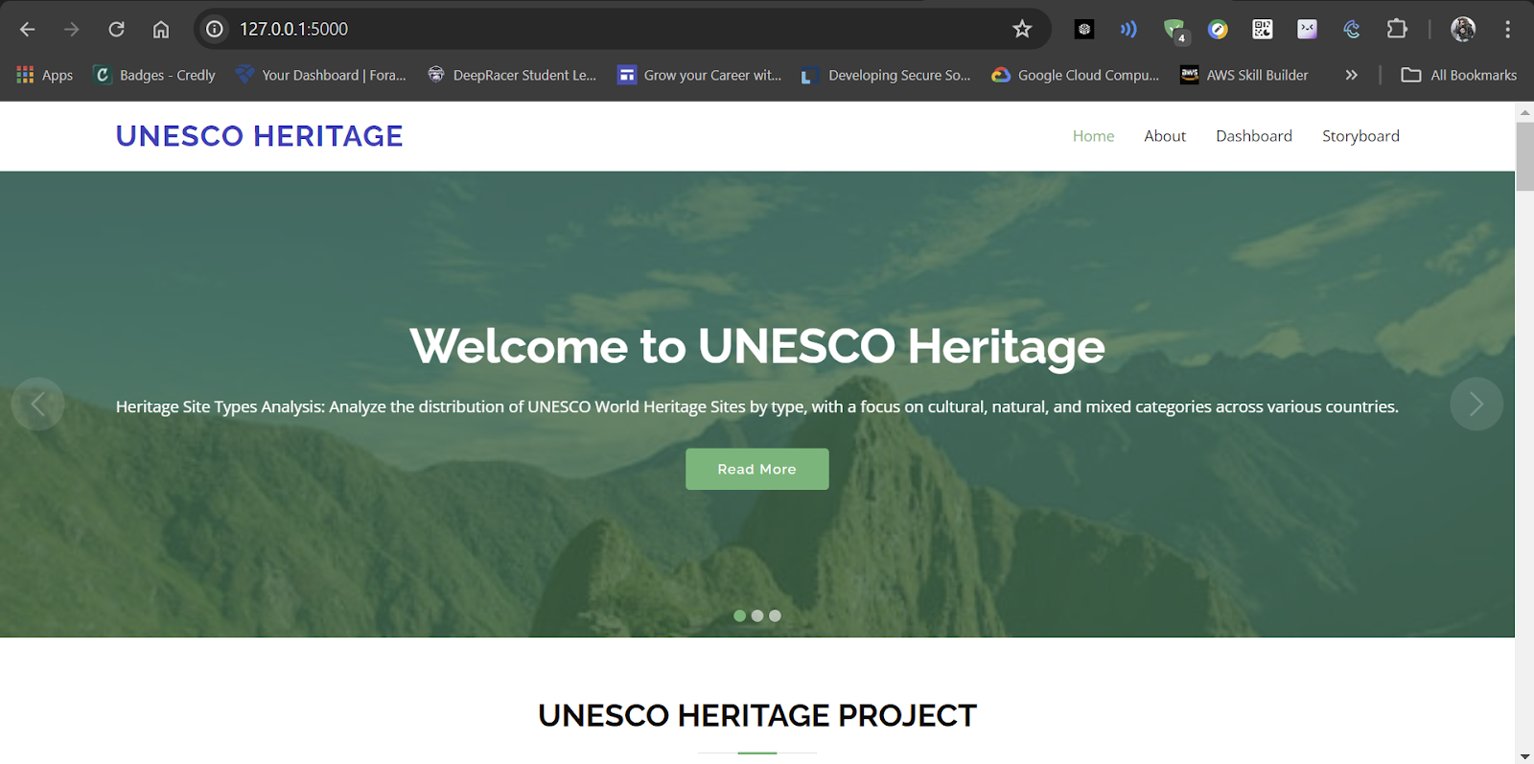



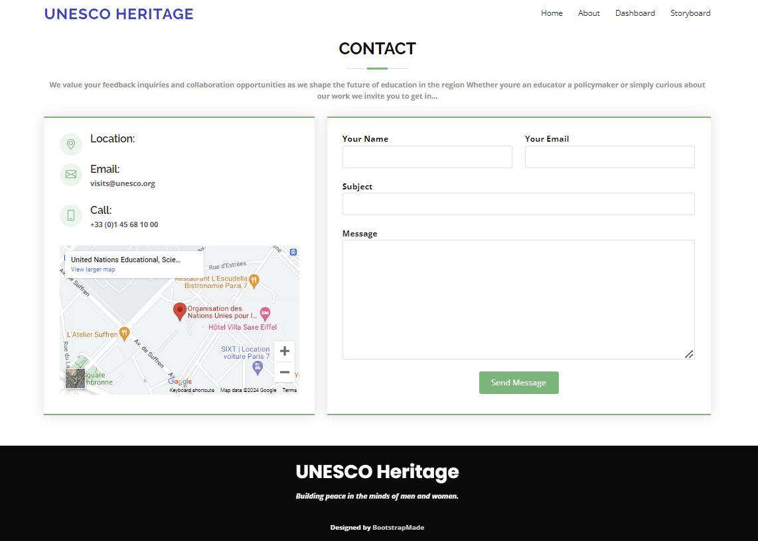

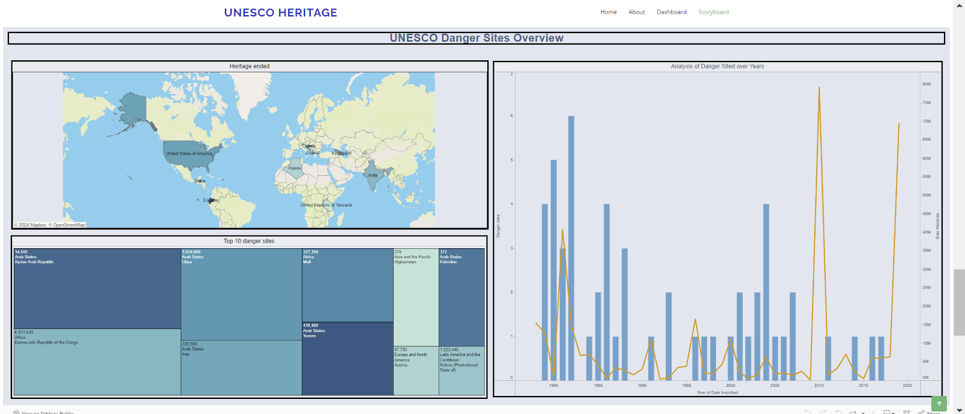

**🖥️ 10. Dashboard & Story Embed with UI using Flask**

**⏱️ Duration:**

**1 Hour**

**🧠 Skill Tags:**

* Flask Web Framework
* Tableau Dashboard Embedding
* UI Integration
* Web Application Development
* HTML & Bootstrap
* Interactive Data Display

**📘 Overview:**

This section of the project involves **embedding Tableau dashboards and stories** into a custom-built **Flask web application**. Flask, a lightweight Python web framework, was used to create a **user-friendly web interface** for presenting interactive visualizations.

**🔗 Features Implemented:**

* ✅ Webpage UI designed using **HTML**, **CSS**, and **Bootstrap**
* ✅ Tableau dashboards and stories embedded using **iframe**
* ✅ Flask routes handle dashboard and story pages
* ✅ Responsive design for desktop viewing
* ✅ Smooth navigation between **Overview**, **Dashboards**, and **Story** sections

**📹 Explanation Video:**

🎥 **File:** TableauFlask.mp4  
This video demonstrates:

* Setting up a Flask project
* Designing the UI using HTML and Bootstrap
* Embedding Tableau Public links into the app
* Running the application locally

**💡 Outcome:**

The dashboards and story are now accessible through a **customized web interface**, making the project **interactive, accessible, and visually appealing**. This also demonstrates how Tableau visualizations can be integrated into real-world web applications.